**AGENCY DEVELOPMENT PROGRAM**

customized for:

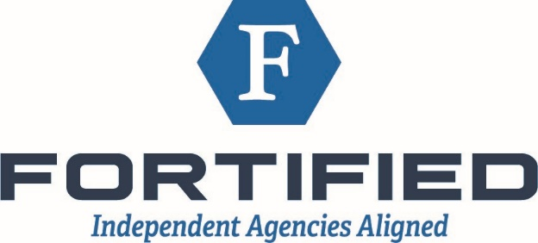

by:

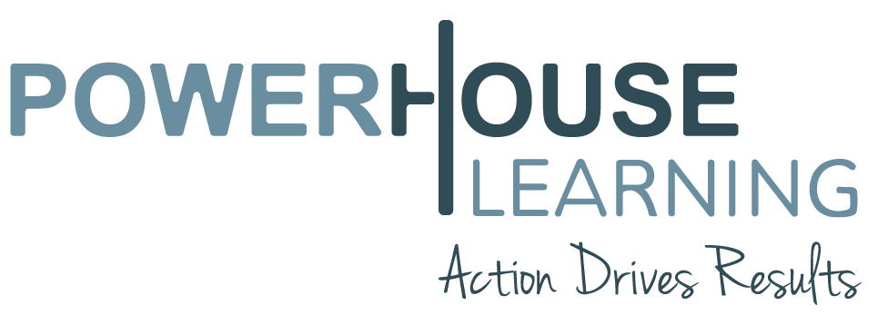

We bring a unique solution addressing one of the insurance industry’s most pressing challenges today…that of developing THE PEOPLE inside an insurance agency towards peak performance. Shedding light on that challenge are several troubling statistics:

* Only 1 out of every 5 newly hired sales people will become successful producers. (The Middleton Group)
* 2 out of 3 newly hired producers will not last 2 years, but will cost the agency 4-6 times the producer’s annual salary. (IIABA Study)
* Industry experts say that, due to an aging baby boomer population, we will lose over *one million* (1,000,000) insurance professionals over the next ten years.

*(No doubt many of us with years in the industry are already experiencing the pain of that prediction!)*

The conventional approaches used in sales training, workshops, and consulting can provide good information, but they clearly are not leaving participants or management with the skills needed to do the most critical for long-term success:

(a.) giving them tools & training to implement adequate change and (b.) showing participants how to create accountability conversation for results.

Using a variety of proven on-site and on-line tools and techniques developed over the past 20 years, we create an environment that facilitates behavioral change for each member of the agency, from the owner/manager to the service team to each producer, *all pulling together to overachieve personal, team, and agency goals.*

**WHAT MAKES US DIFFERENT:**

1. **We address tough core issues** that are typically ignored by traditional methods.
2. Our interactive media curriculum develops individual and organizational commitment and accountability.
3. Experienced coaches teach “thinking ability & skills” and facilitate behavioral change rather than just imparting knowledge.
4. We address *all elements of the agency* recognizing that each influences the sales productivity and performance.
5. Our program is customized to fit your organization’s objectives and unique characteristics.
6. We are results-oriented, conscientious about your time and investment.
7. We can be a part of your team for as long as you’ll have us OR you can use us for a stand-alone DIY product.

**THE PROGRAM INCLUDES:**



**Training with practical, real-world answers.**

**Training curriculum with**

**accountability triggers built in.**

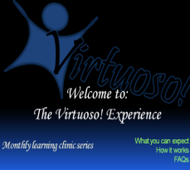

**Coaching and homework that moves**

**teams from DISCUSSION into ACTION.**



**Resource templates for every area of the agencyto make their own and use.**

**DIY VIDEO TRAINING:**

|  |
| --- |
| **App Essentials & Carrier Evaluations** |
| **Building Connections** |
| **Carrier Relations** |
| **Client Evaluations** |
| **Create a Marketing Plan** |
| **Difficult Conversations** |
| **Executing True CRM** |
| **Internet & Personal Marketing** |
| **Negotiations** |
| **Presentations & Proposals** |
| **Procedures** |
| **Psych 101 & Prospecting** |
| **Qualifying** |
| **Referrals Made Easy** |
| **Time Management** |
| **Understanding the Other** |
| **Workflow** |
| **XSARUS** |

**Monthly topics are all inclusive, engaging Leaders, Sales Teams and Service Teams alike.**

### ENGAGEMENT OPTIONS:

**OPTION 1:** ***I WANT TO GO AT MY OWN PACE***

The complete Powerhouse Learning **Agency Development Program** includes:

* A complete video package + customizable templates for:

Leaders

Sales Teams

Service Teams

* Designed to help your agency create optimum performance including over 18 months of a fully self-paced **Producer Development Training**.
* 5-minute express **Train-the-Trainer videos** to help managers create a team learning environment.
* + **Human Resource templates** to help you manage people, processes, and operations*.
* ALL videos in The Virtuoso Experience library including 6 major modules and over 21 topics customized per department designed to **take your agency to the level you’ve been expecting** for years!
* SPECIAL BONUS for Fortified Agents: **Three (3) hours of custom web-cam consulting** from Nationally known industry author, speaker and coach, Brandie (Hinen) Jones. Total value - $1,200 – ***included****!*

**OPTION 1 TOTAL PACKAGE COST (ONE TIME FLAT FEE) $2,217**

**For your own Fortified personal portal:**

<https://powerhouselearning.com/product/fortified-pack/>

### ENGAGEMENT OPTIONS:

**OPTION 2: MY OWN PACE HASN’T WORKED QUITE YET *– LET’S GET GOING!***

**I want ALL** Powerhouse Learning material, videos, templates from OPTION 1, **PLUS** engage Powerhouse Learning as our accountability coach in helping us move to new heights.

**GIVE ME MY FORTIFIED DISCOUNT** based on my:

* agency size,
* culture (unique way of doing things), and our
* short,
* medium &
* long term needs

in the following areas:

* CARRIER RELATIONS/MAXIMIZING REVENUE
* PRODUCER DEVELOPMENT
* ACCOUNT MANAGER EFFICIENCY
* LEADERSHIP/EMERGING LEADERS’ EXECUTIVE COACHING
* CREATING A WINNING GROUP OF SELF-GOVERNING AGENCY TEAM MEMBERS (free of all the drama, whining and complaining)

We’re ready to “move from Discussion into Action”!

**OPTION 2 TOTAL PACKAGE COST IS AGREED UPON BETWEEN POWERHOUSE LEARNING AND EACH FORTIFIED AGENCY WITH SOME OF THE FOLLOWING TERMS:**

* + Starts as low as $1,200/mo
  + Includes a 30-day cancellation clause
  + We may get creative and include 2-4 agencies of similar size and type if they agree to band together for better terms and entertainment value
  + Participants must follow through with ideas presented and be open to learning

**OPTION 3**

**FORTIFIED LEADERSHIP ACADEMY - small groups (6) in concentrated, results**

**FORTIFIED SERVICE ACADEMY - driven curriculum & accountability**

**FORTIFIED SALES ACADEMY - conversation over time-phased plan**

**email for details [Brandie@PowerhouseLearning.com](C:\\Users\\brand\\Dropbox\\BACKUP\\POWERHOUSELEARNING.com\\-CUSTOMERS-\\Fortified\\Brandie@PowerhouseLearning.com)**

### TESTIMONIALS:

### **“improved our relationships with each other, clients, and vendors”**

### “Brandie has helped coach our Senior Management, Executives and Company Officers. Their coaching has helped us work together better as a team, build trust within our various groups, and opened the doors to holding each other accountable for our promises yet maintaining a strong team atmosphere. Ultimately their coaching has improved our relationships with each other and with our outside clients and vendors.”

### **“causing us to be accountable”**

### “the teaching methods create an environment that is energetic and interactive.  in addition, the training does not stop in the classroom; they follow through with our activities, causing us to be accountable for the outcome of our program.”

### **“thinking ability and skills”**

### “What I learned has provided me with the “thinking ability and skills” to improve my relationships with clients, associates, employees, and family.  As a manager in a fast-paced service business, I have developed better skills to manage people and projects. By applying the things I have been taught, I have become effective in setting expectations, motivating people, achieving accountability, and reacting and responding in crisis situations.”

### ****“employees are driving the vision”****

### ***“As owners we do not feel like we are pushing a vision or goals onto employees, but that the employees are driving our vision forward and the vision has become their own. Powerhouse Learning has worked in a BIG WAY for our office.”***

### **“far from just another consulting firm”**

### “The effect of this for me is better, more productive relationships with my employees, peers, children, family and friends. Far from just another consulting firm! Thank you for a real experience.”